**PETROWELL**

**THE UNIQUE GRANULAR SODIUM FORMATE**

Enabling better well constructions since 2002

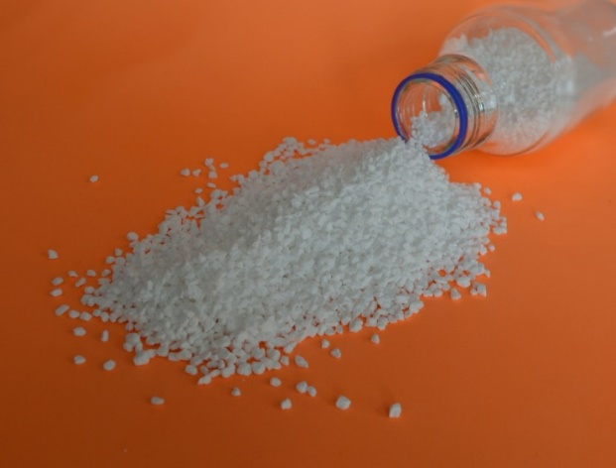

* MKS Marmara has been a supplier of non-caking sodium formate to oilfield fluid service companies throughout the world since 1998.
* MKS PETROWELL is a unique *granulated* non-caking sodium formate, with easy mixing properties, developed by MKS Marmara for Shell in 2002
* MKS PETROWELL is manufactured by MKS Marmara in a special 12,000 MT/annum production facility located at Gemlik, Türkiye, close to a major container ports

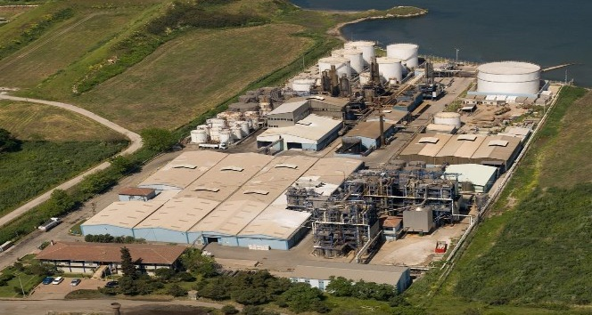

**MKS PETROWELL offers remarkable economic benefits in well construction operations:**

* Fast delivery from stock – via good road, rail and sea links from Türkiye
* Fast mixing in water to make solids-free drilling and completion brines.
* Blend with potassium formate to make brine densities up to 13.1 ppg (SG 1.57)
* Fast, seamless drilling and completion with one fluid – reducing well delivery time.
* High ROP: 50-100% better than oil-based muds
* Better bit performance and longer bit life.
* Better wellbore stability in shales, better hydraulics and lower ECDs
* Elimination of differential sticking
* Improved well control and safety.
* Barite-free: eliminates barite sag problems.
* Faster delivery of oil and gas reserves
* Easy to recycle and reuse.
* Low environmental impact
* Low toxicity to aquatic/marine organisms
* Biodegradable

For more information contact:

|  |  |  |
| --- | --- | --- |
| **Mr. Salih YİĞİT**  Foreign Trade Manager | | |
|  | **Adres**    **Tel**  **Faks**  **Mail**  **Web** | Barbaros Bulvarı Faruk Canıtez Sokak No:8  34353 Beşiktaş/İstanbul, Türkiye  +90 212 258 43 68  +90 212 227 18 95  [salih.yigit@mksmarmara.com](mailto:salih.yigit@mksmarmara.com)  [www.mksmarmara.com](https://emea01.safelinks.protection.outlook.com/?url=http%3A%2F%2Fwww.mksmarmara.com%2F&data=05%7C01%7C%7Ce41467c2b86046f1de8508dbea97fef5%7C84df9e7fe9f640afb435aaaaaaaaaaaa%7C1%7C0%7C638361710795816877%7CUnknown%7CTWFpbGZsb3d8eyJWIjoiMC4wLjAwMDAiLCJQIjoiV2luMzIiLCJBTiI6Ik1haWwiLCJXVCI6Mn0%3D%7C3000%7C%7C%7C&sdata=0ORro%2F%2BO0j%2BJbHTAKQngGYt5ZcTdkcfU6fkeVfPpFlk%3D&reserved=0) |